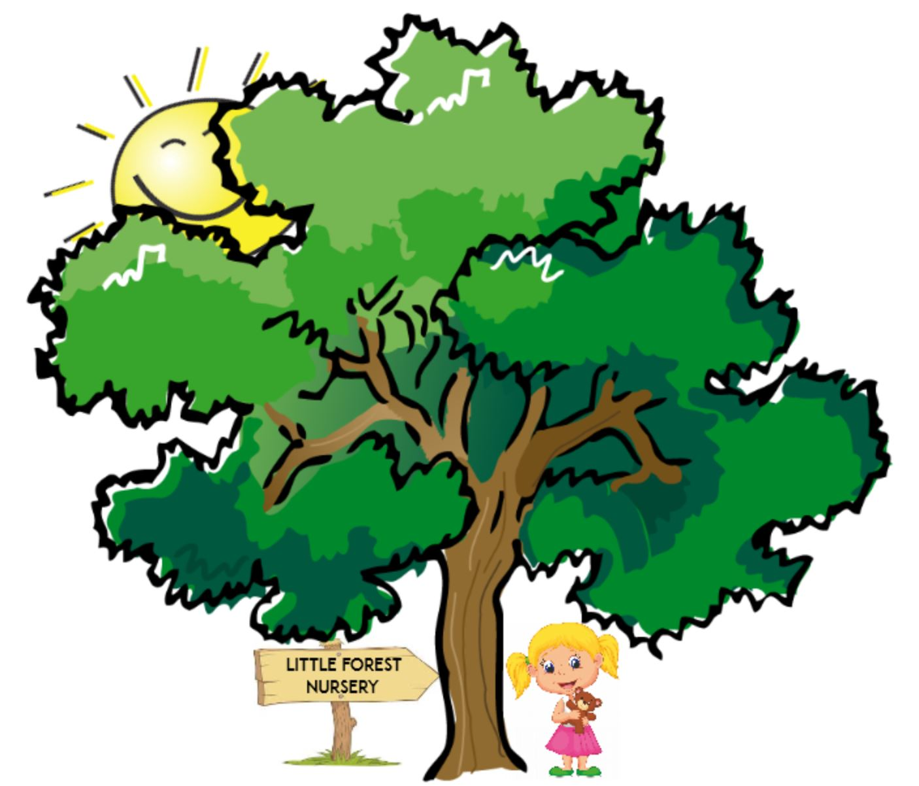 | - Little Forest Nursery Application Form  - Please send to admin@littleforestnurseries.com

Personal Information
Child’s full name:
Parent’s name:
Child’s date of birth:
Home address:
Home phone:
Mobile:
Email address:

What days are you interested in childcare?

Monday Tuesday Wednesday Thursday Friday

What sessions are you interested in?

Half Day School Day Full Day

When would you like your child to start?

_________________________________

Will your child receive funding, if so which type? (for administration purposes only)

______________________________________________________

Where did you hear about us? __________________________________________

